W311MA Plug-and-Play Version can’t install driver automaticlly
Product model: W311MA Plug-and-Play Question catogory: Driver setup

Steps：
1. Install the driver manually;
2. Restart the PC and enjoy wireless.
1) Click the “This PC” icon, find CD drive, right click and select “open”;
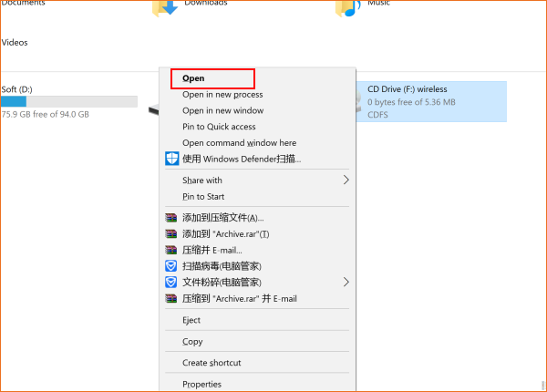
2) Find the “setup” program, double click and start install;
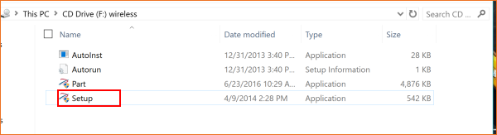
3. Wait the setup progress complete, and the status bar will push a driver install complete message.
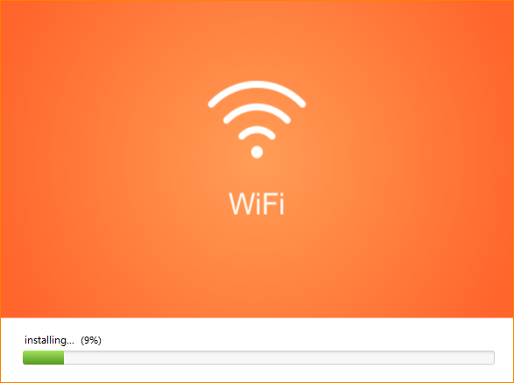
1) Restart the PC.
2) Click the “wireless” icon on the status bar and select a WiFi singal to join in.
